**-Lab Week 5-**

**Problem 1: Sum of Even Numbers**

Write a program that calculates the sum of all even numbers from 1 to N, where N is provided by the user. The program should then display the sum.

Here are the steps:

1. Ask the user to enter a positive integer N.
2. Use a for loop to iterate from 1 to N.
3. Within the loop, check if each number is even (i.e., divisible by 2). If it's even, add it to a running sum.
4. After the loop, display the sum of all even numbers from 1 to N.

For example, if the user enters 6, the program should calculate and display the sum of even numbers from 1 to 6, which is 2 + 4 + 6 = 12.

Paste your code below:

sum = 0

n = int(input("> "))

for x in range(1, n+1):

if x % 2 == 0:

sum += x

print(sum)

Paste the screenshot of your output below:

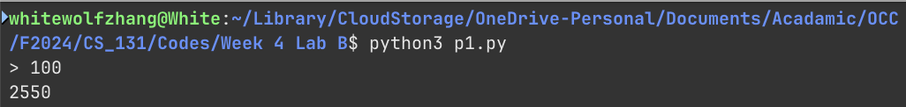

**Problem2 : Multiplication Table**

Write a program that generates a multiplication table for numbers from 1 to N, where N is provided by the user. The table should be displayed in the following format:

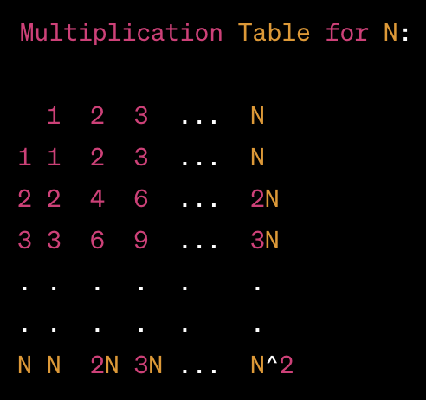

Here are the steps:

1. Ask the user to enter a positive integer N.
2. Check if N is a positive integer. If not, display an error message and ask for input again until a valid positive integer is provided.
3. Use nested loops to generate and display the multiplication table up to N as shown above.

For example, if the user enters 4, the program should generate the following table:

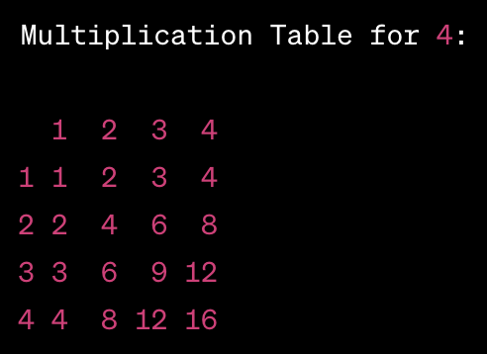

Paste your code below:

from math import log10

n = int(input("> "))

while n <= 0:

print("Positive integer please")

n = int(input("> "))

print(f"Multiplication table for {n}:")

print()

width = int(log10(n * n)) + 1

print(" " * int(log10(n)+1), end=' ')

print(" ".join([f"{i:>{width}}" for i in range(1, n+1)]))

for i in range(1, n+1):

print(f"{i:>{int(log10(n)+1)}}", end=' ')

print(" ".join([f"{j * i:>{width}}" for j in range(1, n+1)]))

Paste the screenshot of your output below:

**Problem3 :** **Problem: Pattern Printing**

Write a program that prints a pattern of stars (*) in the following format:

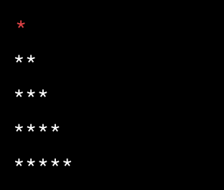

Here are the steps:

1. Ask the user to enter a positive integer N.
2. Use nested loops to print the pattern of stars. The outer loop should iterate from 1 to N, and the inner loop should print the corresponding number of stars on each line.

Paste your code below:

n = int(input("> "))

for i in range(1, n+1):

for j in range(i):

print("*", end='')

print()

Paste the screenshot of your output below:

